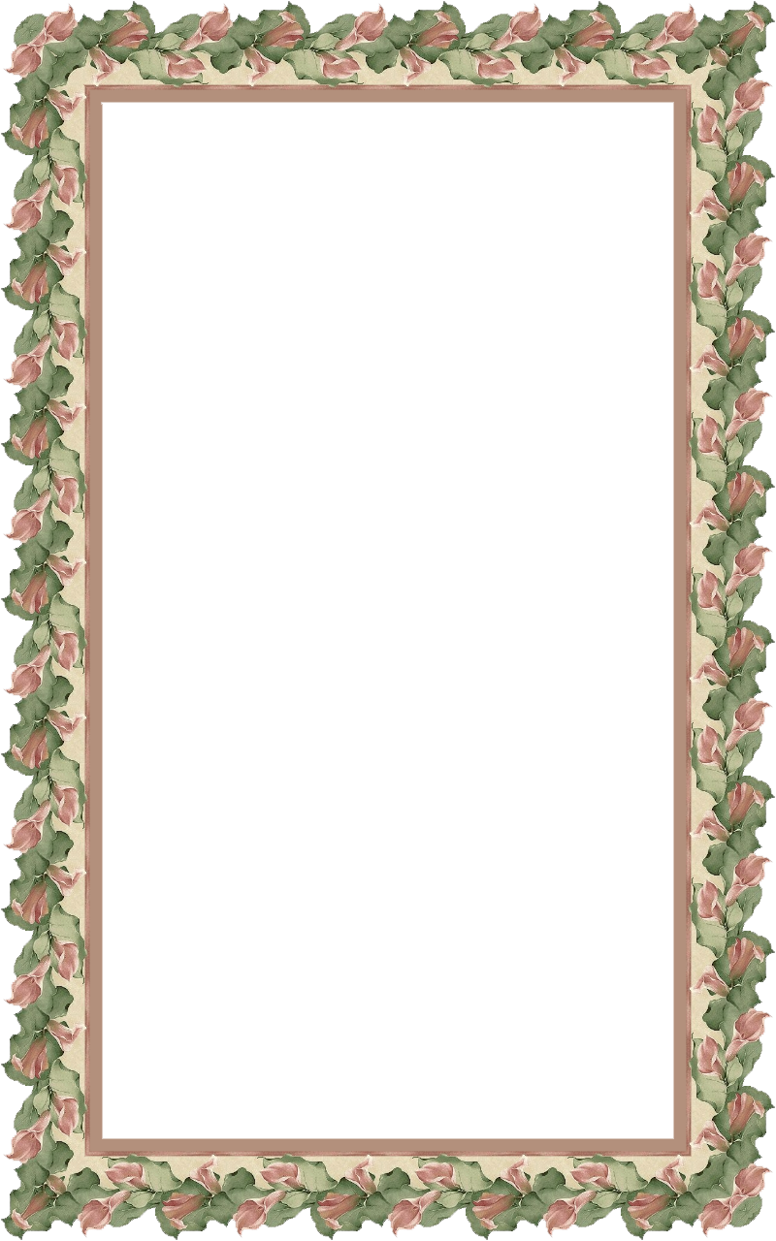
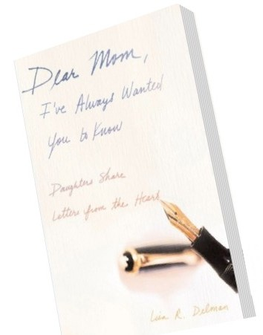

Інноваційні технології в навчанні англійської мови

План-конспект уроку
англійської мови у 8 класі

“THE ART OF WRITING LETTERS”

THE ART OF WRITING LETTERS.

Objectives: – to activate new vocabulary;
- to develop students’ writing skills;
- to teach students the importance of creating formal and informal documents;
- to enrich students’ outlook;
- to involve students to work in groups;
- to form students’ skills in composing informal letters.
Equipment: multimedia complex (laptop, projector, screen), PPT presentation, audio of the song “Open Letter to a Friend” by H-Blockx , brochures “How to Write Good Letter”, signal pictures, cards with tasks, envelope with surprise for pupils, sheets of paper for letters.
PROCEDURE
- INTRODUCTION
- Greeting
- Warm up
Look at the screen, please. (Slide 1)
What is the theme of our lesson?
Why do you think so?
Really our theme today is “The Art of Writing Letters”.
How do you think what we shall speak about?
Think over our epigraph: (Slide 2)

“Letters have to pass two tests before they can be classed as good: they must express the personality both of the writer and of the recipient.”
E. M. Forster
Do you agree with it? Why?
- Aims (Slide 3)
During the lesson you’ll:
- listen to some new information about letters;
- enrich your vocabulary with new words;
- do the different tasks;
- listen to the song;
- work in groups;
- practice in writing letters.
- Motivation (Slide 4)
After the lesson you’ll be able to
- know how to write a good letter;
- know which phrases are suitable for different kinds of letters;
- understand how it is important to write the letter properly;
- write your own letters to your friends.;
- MAIN PART
- Vocabulary (Slide 5)
Let’s see what words we shall use during the lesson. Some of them are known for you and some are not.
- Receiver, recipient – someone who receive something;
- Pillar – a tall upright round post, column, usually made of stone;
- Pigeon – a grey bird that is common in cities; earlier used for delivering messages;
- Envelope – a thin paper cover in which you put and send a letter;
- Postage – the money charged for sending a letter, package etc by post;
- Signature – your name written in the way you usually write it;
- Colon – the sign (:) that is used in writing and printing to introduce an explanation;
- Response – something that is done as a reaction to something that has happened or been said;
- Regard – respect and admiration for someone or something;
- Application – a formal, usually written, request for something;
- Yours faithfully – the usual polite way of ending a formal letter, which you have begun with Dear Sir or Dear Madam.
- Listening (Slide 6)
Communication begins with language, the distinctive ability which has made possible the evolution of human society. With language any message, no matter how complex, can be conveyed between people over a limited distance - within a room or place of assembly, or across a short open space. Another requirement for efficient communication is a system of writing. Messages carved on stone pillars communicate very well across time, down through the centuries, but they are an inefficient method of communicating across space. This requires yet another ingredient in the communication package - a portable writing material such as papyrus. The sending of written messages is a standard feature of government in early civilizations. Much of our knowledge of those times derives from archives of such messages, discovered by archaeologists. The most efficient postal service is that of the Persians. At intervals of a day's ride there are posting stations, where new men and fresh horses will be available at any moment to carry a document on through the next day's journey. Until recent centuries, the only way to increase the speed of communication has been to improve the speed of the messenger.
Domesticated pigeons are first developed in ancient Egypt. Pigeon post is the use of homing pigeons to carry messages. Pigeons were effective as messengers due to their natural homing abilities. The pigeons were transported to a destination in cages, where they would be attached with messages, and then naturally the pigeon would fly back to its home where the owner could read his mail. Pigeons have been used to great effect in military situations.
An invention as useful as printing in a Europe becomes a new stage in mail developing. All governments depend on communication, and throughout history there have been repeated attempts to increase the speed and reliability of the mail.
The first envelopes were made of cloth, animal skins, or vegetable parts. The Babylonians wrapped their message in thin sheets of clay that were then baked.
In 1653, Frenchman, De Valayer established a postal system in Paris. He set up mail boxes and delivered any letters placed in them if they used envelopes that only he sold. This method became popular in other countries and started the modern post service.
If there is one man who can be said to have changed the face of the postal service forever it is Sir Rowland Hill, with his reforms of the postal system based on the concept of penny postage, and his solution of pre payment.In his proposal Hill also called for official pre-printed envelopes and postage stamps as alternative ways of getting the sender to pay for the postage, which led to the invention of the postage stamp, the Penny Black.
The postal system was important in the development of modern transportation. Railroads carried railway post offices. During the 20th century, air mail became the transport of choice for inter-continental mail. Postmen started to utilize mail trucks. The Internet came to change the conditions for physical mail. E-mail (and in recent years social networking sites) became a fierce competitor. The term “e-mail” (short for "electronic mail") first appeared in 1982.
As you see a letter has the long and interesting history because it was really important for people to send and receive letters to each other in any time. And our main task today to learn how to write the letter properly. (Slide 7)
All letters can be divided into formal or business and informal or personal letters.
There are five main parts in a letter. Look at our screen (Slide 8): body, greeting, date, sender, closing. How do you think what is the order of these parts? Try to guess yourselves. (Slides 9-11)

Write down this order: (Slide 12)
- Date
- Greeting (Salutation)
- Body
- Closing
- Sender (Signature)

Informal letters (Slides 13-14)
If you're writing to a close friend, you should write the date, which will help your friend remember when it was received.
Start with a proper greeting. The opening should begin at the left side of the page, not the middle or up against the right side of the sheet. The most common opening is "Dear" followed by the person's first name and a comma. You also can write "Hello“, or "Hey“, or “Hi”.
Write an opening paragraph. You can begin with "How are you?", "What's up?" or "How's it going?”
Construct the body of the letter.
Include a closing such as "Love always" ,"Cheers", "Sincerely", “See you soon", or “Take care“. Sign your name underneath and print your name under the signature.
Formal letters (Slide 15)
Besides the date you should write your address and the address of the receiver on the right. In greeting use Mr., Miss, Mrs., Madam, Dr., Sir before the receiver's last name and a colon instead of a comma, (e.g. "Dear Mr. Johnson:“).
Write an opening paragraph. Be direct about why you are writing the letter. Construct the body of the letter.
Use the closing paragraph to indicate the type of response you are seeking. The closing can be on the left or the right side of the page. Stick with "Regards,“ “Sincerely yours” or "Respectfully," and sign your name underneath. Then print your name under the signature.
- Brainstorming (Slide 16)
Say which phrases are suitable for formal or informal letters:
- 1. Dear Mr. Williams,
- 2. See you later.
- 3. Yours sincerely, Mary
- 4. Hi, how’s it going?
- 5. Lots of love, from Jerry
- 6. Yours faithfully, Alan Stewart
- 7. Dear Madam,
- 8. Dear Jeff,
- 9. Take care
- 10.I look forward to hearing from you soon.
- 11. Sorry I haven’t written for a while.
- 12. Please can you send me an application form?
- 13. Best wishes, from Tracey.
- 14. Please say hi to Peter.
- 15. We are writing to inform you that…

- Group work (Slides 17-18)
Do you like car racing? Let’s play a quiz game.
Instructions:
- Divide into Teams.
- Each team is asked a question. If you answer correctly, I’ll click your team’s color button to move your car.
- Five correct answers will cross the finish line and win the race.
Quiz
- Which letter starts Dear sir?
- How many parts are there in a letter?
- What is the main part of the letter?
- Which part can include the words “Best wishes”?
- Where should you write your name?
- How can you greet your close friend in a letter?
- What do we need to put our letter in to send it by post?
- What punctual sign should we use after closing?
- What phrases are common to start the main part of the letter to a friend?
- Which letter is more complicated: formal or informal?
- What words should we use in formal letter to greet a receiver?
- Where should you write the date?
- What do we usually write in upper right corner in formal letter?
- What paragraph of the letter should explain your reason for writing?
- Should you leave a space between paragraphs?
- What punctual sign should we use after greeting in formal letter?
- Where should you put your signature in a letter?
- What is another name for “Informal letters”?
- In which letter should we use phrase “I am writing to inform you that...”
- In which part can we use phrase "How are you?"
- Where should we write the greeting in the letter?
- In which part can we use phrase “See you soon”?
- How should we call unmarried woman in a letter?
- Who we address informal letters to?
- What is another name for “Greeting”?
- Listening
Now let’s have some relaxation. I know you like listening to music, don’t you? Please listen to the song “Open Letter to a Friend”. While listening try to understand what it is about and do the task. I’ll give you these sheets with the lyrics of the song bur there are gaps in lyrics. You have to fill in the gaps while listening. (Slide 19)
- Writing “Chain letters” (Group work)
Our next activity will be writing letters. Please take these sheets for each group. You have to write a letter to your imaginary friend. You have to write the body of the letter. Every member of the group should write one sentence as minimum but you shouldn’t talk, only read previous sentences and continue the letter with your own one.
(Pupils write letters and then read them.)
- SUMMARY
Let’s see if we have gained our aims. (Slide 20)
- Do you know how to write a good letter?
- Do you know which phrases are suitable for different kinds of letters?
- Do you understand now how it is important to write the letter properly?
- Can you write your own letters to your friends now?
- Home assignment
I want to present you brochure in which you can find useful information connected with the theme of our lesson. It will be your home task to read it for the next lesson. Another task is to write the letter to your close friend according to the rules we studied a t our lesson. You may use the resources of the Internet: http://www.readwritethink.org/files/resources/interactives/letter_generator/ There you’ll find “Letter Generator” which will help you to organize your formal or informal letter correctly.
- Conclusion (Slide 21)
Thank you for your work today. Good job! I think our lesson was useful for you. I want you to remember everything we have talked about because the tradition of writing letters is very interesting and useful at the same time.

