“Healthy way of life.
“Healthy way of life. What does it mean to ве healthy?”

Мета уроку: формування ключових компетенцій( особистісної, соціальної, самоосвітньої, здоров’язберігаючої)

Практичні задачі:
- удосконалювати комунікативні навички, актуалізувати вивчений матеріал та
навчити учнів оперувати ним, вживаючи в лексико- граматичних структурах, реченнях, під час діалогічного і монологічного мовлення.
- розвивати вміння аудіювання тексту та ведення обговорення прослуханого.
Освітні задачі:
- розширити знання учнів про необхідність дотримання здорового способу життя, шляхів та способів збереження і зміцнення власного здоровя.

Розвиваючи задачі:
- розвивати навички монологічного та діалогічного мовлення, читання, вміння вести обговорення тексту;
- розвивати зорову та адитивну пам'ять, критичне мислення під час виконання комунікативних інтерактивних вправ, аналітичні здібності, навички рефлексії;

Виховні задачі:
- виховувати позитивне ставлення до здорового способу життя , піклування про власне здоров’я., культуру спілкування , підвищувати рівень мотивації учнів;

Тип уроку: комбінований

Очікуваний результат;
Розповідати про причини захворювань людини, роз’яснювати наслідки недотримання режиму дня, пропонувати власні поради збереження здоров’я, вести діалогічну розмову, використовуючи адекватні матеріали, висловлюючи власну думку при вирішенні проблем повсякденного життя.

Оснащення уроку: підручник англійської мови для 7 класу(Л. Биркун, Освіта, 2007), тематичні малюнки, прислів’я про здоровя роздруковані завдання для читання тематичного тексту та аудіювання, тематичні слайди, музичний супровід

What does it mean to bе healthy?”

Мета уроку: формування ключових компетенцій( особистісної, соціальної, самоосвітньої, здоров’язберігаючої)

Практичні задачі:
- удосконалювати комунікативні навички, актуалізувати вивчений матеріал та навчити учнів оперувати ним, вживаючи в лексико- граматичних структурах, реченнях, під час діалогічного і монологічного мовлення.
- розвивати вміння аудіювання тексту та ведення обговорення прослуханого.
Освітні задачі:
- розширити знання учнів про необхідність дотримання здорового способу життя, шляхів та способів збереження і зміцнення власного здоров’я.

Розвиваючи задачі:
- розвивати навички монологічного та діалогічного мовлення, читання, вміння вести обговорення тексту;
- розвивати зорову та адитивну пам'ять, критичне мислення під час виконання комунікативних інтерактивних вправ, аналітичні здібності, навички рефлексії;

Виховні задачі:
- виховувати позитивне ставлення до здорового способу життя , піклування про власне здоров’я., культуру спілкування , підвищувати рівень мотивації учнів;

Тип уроку: комбінований

Очікуваний результат;
Розповідати про причини захворювань людини, роз’яснювати наслідки недотримання режиму дня, пропонувати власні поради збереження здоров’я, вести діалогічну розмову, використовуючи адекватні матеріали, висловлюючи власну думку при вирішенні проблем повсякденного життя.

Оснащення уроку: підручник англійської мови для 7 класу(Л. Биркун, Освіта, 2007), тематичні малюнки, прислів’я про здоров’я роздруковані завдання для читання тематичного тексту та аудіювання, тематичні слайди, музичний супровід.
Хід уроку.
I.Початок уроку.
1. Привітання. Комунікативно – ігровий прийом.
Good morning, boys and girls! Nice to see you in good health today. How’s life today? What mood are you in?
Let’s say something good to each other. Turn to your partner and wish something good to your friend. I’ll start “Ann, I wish you to get a good mark today”. (P1 – P2 – P3…)

2. Мотивація до навчання
Гра “Асоціації”- висловлювання учнів із зазначеної проблеми

Warm up
T: Health is above wealth. What does it mean to be healthy? Some people think
it just means not being sick. But being healthy means feeling good, too. It means
having energy to play and to work. You see the Sun on the blackboard, it’s our health. What is health for you? What do you associate with health? And the first task is “Associations”. Write your associations with the word “Health” on these stripes- sunrays and stick to our Sun. You have 3 min. ( учні пишуть свої асоціації під музику,виходять та прикріплюють на дошку) )
Health
?

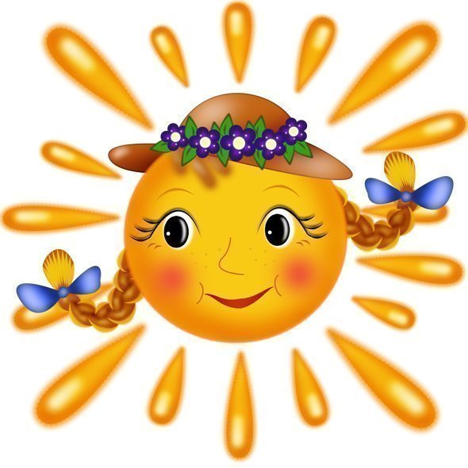 ?

T: Can you tell me what should you do to be fit, to be healthy?
P1: I think we should do morning exercises.
P2: I think young people shouldn't smoke or drink alcoholic drinks. It's harmful to your health
P3: I think we have to go in for sport; we should eat a right food.
Використання прийому “Мікрофон” учні озвучують свої думки.
To my mind health is… I think health is…
I’m sure health is… I agree with my classmates that health is…

3. Повідомлення теми та задач уроку.
“ Why-questions” game.
T: Today we'll speak about a healthy way of life and the motto of our lesson is: “The first wealth is health”. How do you understand this motto? Do you agree with it? Why?

II. Основна частина
1) Актуалізація знань, робота в групах, лексико- граматичні вправи:
а) Імітаційно-моделююча гра «Визначення стану свого здоров’я»
T: Are you healthy? Let’s check. All of you have three different circles. Listen me and choose the colour of your health, go to the board and stick it on the poster.
- if you fall ill during the year and seldom miss lessons – you’re healthy;
- if you fall ill mostly during the epidemies – you’re healthy in some way;
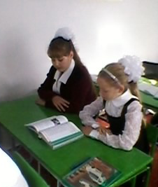
- if you often fall ill during the year and miss your lessons – your health is in danger.

T: I see that some pupils don’t feel yourselves healthy? From time to time they have problems and have to see a doctor.
b) Робота в парах.
Students get handouts. They have to set the words in 3 groups:

parts of the body, diseases, symptoms.
( toothache, sneezing, heart attack, tuberculosis, chicken pox, ankle, bronchitis, headache, eye, sore throat, stomach, nose, ect.)
c) . Match the phrases.
1) Go for a) smoking;
2) look after b) yourself;
3) put on c) your lifestyle;
4) give up d) a check up;
5) keep in e) your teeth;
6) take up f) weight;
7) change g) a sport;
8) brush h) shape.

d) Reading. Читання
Pre-reading.
- Give the meaning of the following words: disgusting, dangerous, sunflower seeds, hurry home a yoga class, cookery class, germs;
While-reading
Read the text “Healthy Henry”and try to work with it. ( Ex.5,p.63)
- Say if the statements are true or false:
a) Henry does his morning exercises for 30 minutes.
b) Boiled eggs and sandwich with cheese and butter is good for him.
c) He doesn’t use the public transport because he is sure that it’s very dangerous.
d) His lunch consists of sunflower seeds and one onion.
e) He never plays computer games, because it’s bad for his eyes.
f) Henry attends yoga class and cookery class.
g) He prefers to sleep in a tent in hot weather.

Post-reading
Discussion
- Where does Henry work?
- What time does he get up at?
- What does he do in the morning?
- How does he get to the work?
- What does Henry eat for breakfast and lunch?
- Where does he go on Monday and Thursday?
- Where does he spend his summer?

- 2) Pольова гра
“A visit to a doctor”
- Good-day, I'm Dr. Stevens. What is your name?
- My name is Peter.
- What's the matter with you?
- I've a splitting headache, a sore throat and a running temperature.
- First of all: I shall feel your pulse. Give me your hand, please. Thanks. So, let me examine your throat. Where is a small spoon? Open your mouth, please. Your throat is red. Let me listen to your heart and lungs. Strip to the waist and breathe.
- What's the matter with me, doctor?
- You have a bad cold. You must stay in bed for 2 days, until your temperature is normal and you stop coughing. I shall prescribe you some medicine. Ask your mother to go to the chemist's and get the medicine. Now I shall give you a tablet for headache. If you follow my recommendations you will recover very soon.
- Thank you, doctor.
- Be healthy.
- Інсценізація.
A visit to the physician
- Physician: Hello!
- Anya: Hello!
- Physician: What`s the matter? You don`t look happy.
- Anya: I don`t feel well. I`ve got a headache and an earache. My ear hurts. And I can`t move my head.
- Physician: How long have you been this?
- Anya: Since yesterday.
- Physician: What is your temperature?
- Anya: It is 37.5.
- Physician: You shouldn`t worry. You should stay in bed and keep warm yourself. I`ll prescribe some medicines for you. Take the medicine three times a day before meals. Take some vitamins, too. You should drink tea with honey or raspberry jam .
- Anya: Thank you very much. Good bye.
- Physician: Good bye.

3) Relaxation.
Pupils have a short rest, listen to the song “What a wonderful world” by Louis Armstrong, try to sing themselves and enjoy the slide-show.

4) Аудіювання
Pre-listening
Імітаційно- моделююча гра

T: Now I want you to listen to our school doctor about healthy lifestyle and then discuss it. (доповідь учня)
Depends- залежати
Prevent- запобігати, захищати
Destroy- руйнувати
Care- піклуватися

While- listening

Different people have different life style and sometimes we don’t care about what we eat , drink, how much we sleep, sit in front of the TV or computer monitor, rest and exercise. Our health depends on our lifestyle. The meal we eat should be healthy, balanced and home- made. You should eat less sugar and fat, but more fruit and vegetables, a lot of vitamins every day. All juices are good for health: tomato, apple, apricot and of course pine-apple juice. Vitamin "C" is good for our health. Garlic prevents us from cold. As you know: "An Apple a Day Keeps the Doctor Away". Don't read or watch TV when you eat. Have only healthy snacks .Forget about junk and fast food, high-fat, high-calorie snacks: cookies, potato chips and soda. Make your own sandwiches with meat and vegetables. Drink a lot of water Your body needs a lot of water. Don't eat after 7 p.m.
Physical activity is very important for a healthy lifestyle. Another good advice is doing sport regularly. Do some exercise in the morning or in the afternoon every day: ride a bicycle, go swimming or jogging, wash the floors in your home or walk the dog.
Don’t be nervous. Avoid stressful situations and try to solve your problems quickly. Get positive emotions, smile and laugh as often as possible.
Bad habits( smoking, drinking alcohol, taking drugs) destroy our organism. They are very dangerous especially for teenagers. Stop and take care of yourself. because your health is the best riches in your life.
True/False
T: You have listened the article. And I'll tell you some statements on a healthy lifestyle and you'll say if they are true, false or you don't know.
T: You should do morning exercises to be fit.
P1: It is true. Physical activity is very important for a healthy lifestyle.
T: You should eat more fruit and vegetables and less sugar and fat.
P2: It is true. You should eat smaller portions but not skip meals.
T: You can read or watch TV when you eat.
P3: It is false. You should not read or watch TV when you eat. You should concentrate on your food.
T:You should drink a lot of water.
P2: It is true. You should drink at least two litres of water every day.
T: You can eat any time you want.
P3: It is false. You should not eat after 7 p.m.
T: Only swimming and jogging can help you burn calories.
P7: It is false. Everything you do - riding a bicycle, go swimming or jogging, washing the floors in your home or walking the dog - burns calories.

Post – listening
Writing. Complete the sentences
T: Listen to the text once more and complete these sentences.
5) Робота в групах за методом “Коло ідей”- висловлювання учнів із зазначених проблем
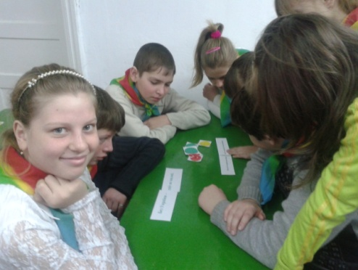
Group№1 Students in this group work out their own rules for health and discuss some problems of healthy food.
The motto of the group: Live not to eat, but eat to live.
- If you want to be healthy you must eat healthy food which contains carbohydrates, fats, minerals. They are in meat, fish, eggs, cheese, butter, oil, nuts, bread, cereals.
- Don’t overeat – it’s very bad for your health. Don’t eat hot meals, don’t eat very quickly and don’t speak while eating.
- You must also eat a lot of vitamins A,B,C.
- You should eat healthy, balanced and home- made food, not fast food or junk food.
- Don’t miss your main meal. Hot dishes are useful for your stomach.
- Black currants, apples, lemons, onions are full vitamin C. When you are ill, drink tea with lemon and it’ll help you.
Group№2 Students in this group work out their own rules for health and discuss some problems of physical activity.
The motto of the group: A healthy mind in a healthy body.
- We think to be healthy people should go in for sport and do exercises regularly.
- There are a lot of sport you can go in for: swimming, running, skating, skiing.
- Sport helps people to keep fit, healthy and strong.
- Sport helps people to be more organized and better – disciplined.
- If you go in for sport you are always active, energetic, full of life.
Group№3 Students in this group work out their own rules for health and discuss some problems of emotions and feelings..
The motto of the group: Early to bed, early to rise, makes a man healthy, wealthy and wise.
- Do you know that 1 min of laughing is as useful as 45 min of physical training lesson? 5 min of laughing is the same as 200 grams of sour cream.
- When you laugh, you breath better, your blood better circulates and your brains gets more oxygen.
- 10 min of laughing helps to forget about all pains for 2 hours.
- Avoid stressful situations and try to solve your problems quickly
- Look at each other and smile!
III. Закінчення уроку.
- Підсумки уроку. Рефлексія. Коментування успіхів дітей на уроці.
T: I’m sure, my dear pupils, you have understood how it is important to keep healthy life style. Now I want you to answer my questions. If you agree – clap your hands, disagree – stamp your feet. Ready?
- Can we drink cold milk?
- Does tea with lemon help you when you are ill?
- Should you do exercises regularly?
- Can we eat ice-cream in winter?
- Should we clean teeth every morning?
- Should we eat fast food?
- Should we go in for sport?
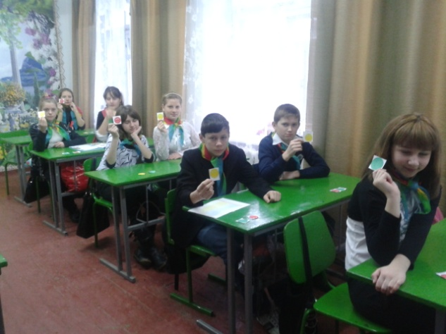
T: Very good ! Well done! You have worked excellent today! Your marks are: …...
If you liked our lesson and understood everything, show me you impressions with the help of smiles. ( учні малюють смайлики)

I wish you to be healthy, clever, strong, kind, happy. Be healthy! Thank you for the lesson. The lesson is over. See you next lesson.
2. Homework : I- Write some “Do’s” to keep in good health.
II- Prepare a report or presentation “Healthy way of life. Health Care”

